#### A Project Report on

**SPARKLING STARS FOR SMART CITIES**

***Submitted in the partial fulfillment of the requirements for the Summer Internship of***

**BACHELOR OF TECHNOLOGY**

In

**COMPUTER SCIENCE ENGINEERING**

Submitted by

M.NEHA 187Y1A05E6

K.RAVALIKA 187Y1A05F2

P.BHAVYASRI 187Y1A05C7

A.BHAGYA REKHA 187Y1A05C6



**DEPARTMENT OF INFORMATION TECHNOLOGY**

**VNR Vignana Jyothi Institute of Engineering & Technology**

(Autonomous Institute, Accredited by NAAC with ‘A++’ grade and NBA)

##### Bachupally, Nizampet (S.O.) Hyderabad- 500 090,

August 2020

**A Project Report on**

**SPARKLING STARS FOR SMART CITIES**

***Submitted in the partial fulfillment of the requirements for the Summer Internship of***

**BACHELOR OF TECHNOLOGY**

In

**COMPUTER SCIENCE ENGINEERING**

Submitted by

M.NEHA 187Y1A05E6

K.RAVALIKA 187Y1A05F2

P.BHAVYASRI 187Y1A05C7

A.BHAGYA REKHA 187Y1A05C6

**Under the esteemed guidance of**



**PROJECT GUIDE**

A.S.V Vandana Assistant Professor,

Dept. of Information Technology, VNRVJIET

**DEPARTMENT OF INFORMATION TECHNOLOGY**

**VNR Vignana Jyothi Institute of Engineering & Technology** (Autonomous Institute, Accredited by NAAC with ‘A++’ grade and NBA) Bachupally, Nizampet (S.O.) Hyderabad- 500 090,

### August 2020

**VNR Vignana Jyothi Institute of Engineering & Technology**

Autonomous Institute, Accredited by NAAC with ‘A++’ grade and NBA) Bachupally, Nizampet (S.O.) Hyderabad- 500 090

**DEPARTMENT OF INFORMATION TECHNOLOGY**

Date: August 2020



**CERTIFICATE**

This is to certify that the project work entitled **“SPARKLING STARS FOR SMART CITIES”** is being submitted by **M.NEHA (187Y1A05E6),**

**K.RAVALIKA (187Y1A05F2), P.BHAVYASRI (187Y1A05C7), A.BHAGYA REKHA (187Y1A05C6)**in partial fulfilment for the award of Degree of **BACHELOR OF TECHNOLOGY** in **COMPUTER SCIENCE ENGINEERING** to the Jawaharlal Nehru Technological University, Hyderabad during the academic year 2019-20 is a record of bona-fide work carried out by her under our guidance and supervision.

The results embodied in this report have not been submitted by the students to any other University or Institution for the award of any degree or diploma.

**ProjectGuide Head ofDepartment**

**Mrs.A.S.V Vandana, Dr. G. SURESHREDDY**

**AssistantProfessor, Head ofDepartment,**

**Dept.ofIT, Dept. ofIT,**

**VNRVJIET, VNRVJIET,**

**Hyderabad. Hyderabad.**

**VNR Vignana Jyothi Institute of Engineering & Technology**

Autonomous Institute, Accredited by NAAC with ‘A++’ grade and NBA) Bachupally, Nizampet (S.O.) Hyderabad- 500090.

**DEPARTMENT OF INFORMATION TECHNOLOGY**

Date: August 2020

#### DECLARATION

##### I hereby declare that the project entitled “**SPARKLING STARS FOR SMART CITIES**” submitted for the B.Tech Degree is my original work and the project has not formed the basis for the award of any degree, associate ship, fellowship or any other similar titles.

Signature of the Student:

M.Neha K.Ravalika P.Bhavyasri A.Bhagya rekha

(187Y1A05E6) (187Y1A05F2) (187Y1A05C7)(187Y1A05C6)

Place: Date:

**ACKNOWLEDGEMENT**

We express our deep sense of gratitude to our beloved **President, Dr.D.N.Rao, VNR Vignana Jyothi Institute of Engineering &Technology** for the valuable guidance and for permitting us to carry out this project.

With immense pleasure, we record our deep sense of gratitude to our beloved **Principal, Dr.C.D.Naidu** for permitting us to carry out this project.

We express our deep sense of gratitude to our beloved professor **G.Suresh Reddy, Associate Professor and Head, Department of Information Technology, VNR Vignana Jyothi Institute of Engineering & Technology, Hyderabad-90** for the valuable guidance and suggestions, keen interest and through encouragement extended throughout period of project work.

We take immense pleasure to express our deep sense of gratitude to our beloved Guide **Mrs.A.S.V Vandana, Assistant Professor in Information Technology, VNR Vignana Jyothi Institute of Engineering & Technology, Hyderabad,** for her valuable suggestions and rare insights, for constant source of encouragement and inspiration throughout my project work.

We express our thanks to all those who contributed for the successful completion of our project work.

1. M.NEHA
2. K.RAVALIKA
3. P.BHAVYASRI
4. A.BHAGYA REKHA

#### A Project Report on

**SPARKLING STARS FOR SMART CITIES**

***Submitted in the partial fulfillment of the requirements for the Summer Internship of***

**BACHELOR OF TECHNOLOGY**

in

**COMPUTER SCIENCE ENGINEERING**

##### Submitted by

M.NEHA 187Y1A05E6

**Under the esteemed guidance of**

**PROJECT GUIDE**

Mrs.A.S.V VandanaAssistantProfessor,

Dept. of Information Technology, VNRVJIET

**DEPARTMENT OF INFORMATION TECHNOLOGY**

**VNR Vignana Jyothi Institute of Engineering & Technology** (Autonomous Institute, Accredited by NAAC with ‘A++’ grade and NBA) Bachupally, Nizampet (S.O.) Hyderabad- 500 090,

### August 2020

#### A Project Report on

**SPARKLING STARS FOR SMART CITIES**

***Submitted in the partial fulfillment of the requirements for the Summer Internship of***

**BACHELOR OF TECHNOLOGY**

in

**COMPUTER SCIENCE ENGINEERING**

##### Submitted by

K.RAVALIKA 187Y1A05F2

**Under the esteemed guidance of**

**PROJECT GUIDE**

Mrs.A.S.V Vandana Assistant Professor,

Dept. of Information Technology, VNRVJIET

**DEPARTMENT OF INFORMATION TECHNOLOGY**

**VNR Vignana Jyothi Institute of Engineering & Technology** (Autonomous Institute, Accredited by NAAC with ‘A++’ grade and NBA) Bachupally, Nizampet (S.O.) Hyderabad- 500 090,

### August 2020

#### A Project Report on

**SPARKLING STARS FOR SMART CITIES**

***Submitted in the partial fulfillment of the requirements for the Summer Internship of***

**BACHELOR OF TECHNOLOGY**

in

**COMPUTER SCIENCE ENGINEERING**

##### Submitted by

P.BHAVYASRI 187Y1A05C7

**Under the esteemed guidance of**

**PROJECT GUIDE**

Mrs.A.S.V Vandana Assistant Professor,

Dept. of Information Technology, VNRVJIET

**DEPARTMENT OF INFORMATION TECHNOLOGY**

**VNR Vignana Jyothi Institute of Engineering & Technology** (Autonomous Institute, Accredited by NAAC with ‘A++’ grade and NBA) Bachupally, Nizampet (S.O.) Hyderabad- 500 090,

### August 2020

#### A Project Report on

**SPARKLING STARS FOR SMART CITIES**

***Submitted in the partial fulfillment of the requirements for the Summer Internship of***

**BACHELOR OF TECHNOLOGY**

in

**COMPUTER SCIENCE ENGINEERING**

##### Submitted by

A.BHAGYA REKHA 187Y1A05C6

**Under the esteemed guidance of**

**PROJECT GUIDE**

Mrs.A.S.V Vandana Assistant Professor,

Dept. of Information Technology, VNRVJIET

**DEPARTMENT OF INFORMATION TECHNOLOGY**

**VNR Vignana Jyothi Institute of Engineering & Technology** (Autonomous Institute, Accredited by NAAC with ‘A++’ grade and NBA) Bachupally, Nizampet (S.O.) Hyderabad- 500 090,

**August 2020**

**INDEX**

|  |  |  |
| --- | --- | --- |
| **S.NO** | **Contents** | **Page no** |
| **1.** | **ABSTRACT** | **i** |
| **2.** | **LIST OF TABLES** | **Ii** |
| **3.** | **LIST OF FIGURES** | **Iii** |

**CHAPTER 1: INTRODUCTION 1-3**

1.1: PURPOSE OF PROJECT 1

1.2: EXISTING METHODOLOGY&DISADVANTAGES 2

1.3: PROPOSED SYSTEM AND ADVANTAGES 2

1.4: OBJECTIVE 3

1.5: THESIS ORGANIZATION 3

**CHAPTER 2: LITERATURE SURVEY 4-7**

2.1: PRINCIPLE 6

2.2: CONCEPT BEHIND AUTO INTENSITY 6

CONTROLOF LED USING ARDUINO

2.3: WORKING PRINCIPLE 7

**CHAPTER 3: ISSUES AND CHALLENGES, ANAYSIS 9-18**

3.1: INTRODUCTION 9

3.2: SOFTWARE REQUIREMENT SPECIFICATION 10

3.3: CONTENT DIAGRAM 11

3.4: ISSUES 16

3.5: CHALLENGES 17

3.6: FUTURE 18

**CHAPTER 4: METHODOLOGY 19-29**

4.1: INTRODUCTION 19

4.2: PROPOSED APPROACH AND FLOW DIAIGRAMS 20

4.3: MODULE DESIGN &ORGANIZATION 27

4.4: SUMMARY 29

**CHAPTER 5: IMPLEMENTATION 31-35**

5.1: SYSTEM OVERVIEW 31

5.2: CIRCIUT DIAGRAM FOR INTENSITY CONTROL OF LED 32

5.3: EXECUTION 35

**CHAPTER 6: RESULT 42**

**CHAPTER 7: CONCLUSION 45**

**CHAPTER 8: FUTURE WORKS 46**

**CHAPTER 9: REFERENCES 47**

**ABSTRACT**

In this project we are going to build a Auto Intensity Control of Power LED Using

Arduino. Sometimes we forget to turn off the lights and waste electricity and you

Must have also seen street light turned on in the day. in this circuit we are not only

Turning On and off lights based on light conditions but also varying the intensity

of light according to outside light conditions. Here by using LDR and PWM concept

for the increase or decrease of the brightness of LED automatically.

**LIST OF TABLES:**

**TABLE NO TABLE TITLE PAGE NO.**

3.1 SOFTWARE REQUIREMENTS 10

3.2 HARDWARE REQUIREMENTS 11

**LIST OF FIGURES:**

**Fig No Fig Name Page No**

2.1 CIRCUIT DIAGRAM 7

3.3 ARDUINO UNO CONTENT DIAGRAM 12

4.1 ESSENTIAL USE CASE DIAGRAM 23

4.2 CLASS DIAGRAM 24

4.3 SEQUENCE DIAGRAM TO RECORD 25

4.4 ACTIVITY DIAGRAM FOR COMPUTER

APPLICATION 26

4.5 COMPONENT DIAGRAM 26

4.6 CIRCUIT DIAGRAM OF LDR 28

5.1 BLOCK DIAGRAM 31

5.2 CIRCUIT DIAGRAM FOR AUTO INTENSITY 33

CONTROL OF LED

5.3 ARDUINO IDE SKETCH 37

5.4 PASTING THE CODE 37

5.5 SAVING THE SKETCH 37

5.6 SPECIFYING LOCATION 38

5.7 NAMING THE FILE 38

RESULT AFTER COMPILATION:

6.1 LIGHT INTENSITY AT 80%OUTPUT 41

6.2 LIGHT INTENSITY AT 50%OUTPUT 43

6.3 LIGHT INTENSITY AT 0%OUTPUT 44

**CHAPTER 1**

**INTRODUCTION**

**1.1: Purpose of the project**

In this project home automation refers to domestic environment that improves the quality of the resident’s.. life by facilitating a flexible, comfortable, healthy, and safe environment. Internet based home automation systems become the most popular home automation system in international markets . The remote controlling and monitoring of a house using internet requires computer, which is large in size and heavy to carry around. The most available home automation systems use different wireless communication standard to exchange data and signaling between their components, like Bluetooth, Zigbee, Wi-Fi, and finally the Global System for Mobile Communication (GSM). Wireless based home automation systems decrease installation cost and effort, and enhance system flexibility and scalability.

In this project, we address the issue of Auto intensity control of led. Intensity control of led is useful to control the home appliances and also can be used to save the power consumption and electricity. Using this we can automatically control the intensity of light based on the outside light conditions.

**1.1.1: MOTIVATION**

The motivation behind this project is that there is a need for simple cost effective portable Auto intensity control of power led using arduino to control the intensity of light based on outside light conditions.

**1.2: Existing methodology and its Disadvantages**

The Existing system is that we will find some people forget to turn off the lights in some of the cases and we can even find the street lights will be turned on in the day time. So it is the waste of electricity and the electricity bill also be very high. So to overcome this problem we are using Auto Intensity Control of Power LED Using Arduino.

**DISADVANTAGES:**

Some of the disadvantages of existing system are

* It is not much flexible
* There is no good range of scalability
* There is no security and authentication

**1.3: Proposed system and its Advantage**

* Proposed system is that we can turn off lights automatically if it is bright outside and turns ON if it is dark outside. But this time, in this circuit we are not only turning On and off lights based on light conditions but also varying the intensity of light according to outside light conditions.
* Here we have used LDR and PWM concept with Arduino for decreasing or increasing the brightness of the 1 watt Power LED automatically

**ADVANTAGES:**

* It allows more flexibility through android device.
* It allows a good range of scalability.
* It provides security and authentication.
* Additional vendors can be easily added.

**1.4: Objective**

The objective of this project is to develop intensity controlled leds. Based on the intensity of outside light conditions led glows according to the intensity The main objectives of our project are as follows:

* To save time and utilize the energy efficiently.
* Controlled by any device capable of Wi-Fi(Android, ios, pc)
* Extensible platform for future enhancement.

**1.5:Thesis Organization**

**Chapter 1:** Describes motivation, scope, objective and problem definition are discussed.

**Chapter 2:** Explains literature survey and basic concepts and terms.

**Chapter 3:** Discusses about user requirements, software and hardware requirements.

**Chapter 4:** Discusses about module design and UML diagrams.

**Chapter 5:** Discusses about system implementation like method of implementation and experimental results.

**Chapter 6:** Discusses about testing and validation.

**Chapter 7:** Discusses about conclusion and future enhancements of the project **Chapter 8:** Provides references.

**CHAPTER 2**

**LITERATURE SURVEY**

Chapter 2 reviews the various studies carried out using existing techniques that have been applied in the field of smart phone controlled home automation .As per our survey, there exist many systems that can control home appliances using android based phones/tablets. Each system has its unique features. Currently certain companies are officially registered and are working to provide better home automation system features. Following models describes the work being performed by others.

Light control system using Ldr and arduino is a whole new idea in the world of Lights. In the wake of experiencing numerous exploration papers which were found on the lighting system were only based on their working and not on the consumption of energy or electricity the main thought process of doing this extend make another diagram system for the road lights that don't eat up massive measure of energy and light up tremendous zone with high force. Savvy Street lights system is a basic bit of the making shrewd city which speaks to 10-45% of total power uses which is a segregating mindfulness toward general society powers utilization. So it is key and profitable essentialness method for progressions are to be executed for fiscal and standardized savings. that too a large portion of the papers are based on the infrared collecters and very few of them are based on the working of LDR and LED by clock method or by the human. Some were found to be controled by the remote GSM/GUI systems which will likewise devour heaps of energy . Programmed Street light is the winged animal from Flintstones which will naturally kill on and all the road lights without daylight

and turn it off within the sight of daylight so it will expend heaps of energy. Worldwide Journal of Engineering Research and General Science Volume 4, Issue 2, March-April, 2016 ISSN 2091-2730 785 www.ieee.org Ancient Lighting framework have been kept to two alternatives on and off, because of it had their own offer of hindrance. This sort of activity implied vitality misfortune because of constant task greatest voltage however genuine necessity may be less relying outwardly condition wheather light is requiredor not . The most straightforward answer to it is by adjusting lights as indicated by the outside condition. This is the thing that we are expecting to do in our savvy lighting framework.

We are living in the world where everything goes to be automatic from your washing machine to your ceiling fan. The world revolves around the word automation and the ones that are automated are said to be of next generation because they limit the involvement of humans. They are self-sufficient to operate on their own and thereby, saving time and cost by being more efficient than the manual ones. But lighting systems have yet to make its move in these automated crusade. We have just started the crusade in our attempt here.

**2.1:Principle**

The principle of this project is to implement an auto-intensity control of LED-based on LDR which is interfaced to an Arduino board. As the surrounding light decreases slowly from evening to night, the light intensity gradually increases and then gets gradually decreased from night to early dawn hence saves energy .Thus, the lights switch on at the dusk and light intensity increases till midnight and regressively decrease till dawn and then finally switch off automatically. The process repeats every day. As stated earlier, application

includes: park lights, street lights, head light in automobile and many unexplored options. Relay is used to provide isolation between Arduino and 220 volt AC supply. The goal is to reduce the amount of energy consumed and thereby reducing the cost incurred due to energy loss thus proving to be a cost-effective strategy.

**2.2:Concept behind Auto Intensity Control of LED using Arduino**

Before going into the circuit diagram, components and code, I want to talk a little bit about the idea behind the project Auto Intensity Control of Street Lights using Arduino. I won’t compare it with any other projects but just dive into the concept.I have used a combination of RTC Module (DS3231) and LDR for controlling the street lights. This combination is not something new but the way it is implemented is.

Basically, there are two modes of operation of this project: RTC Mode and LDR Mode. In RTC Mode, the street lights turn on automatically based on the ON Time set in the code and turn off based on the OFF Time.In the LDR Mode, the street lights have an intensity control based on the ambient light near the LDR.

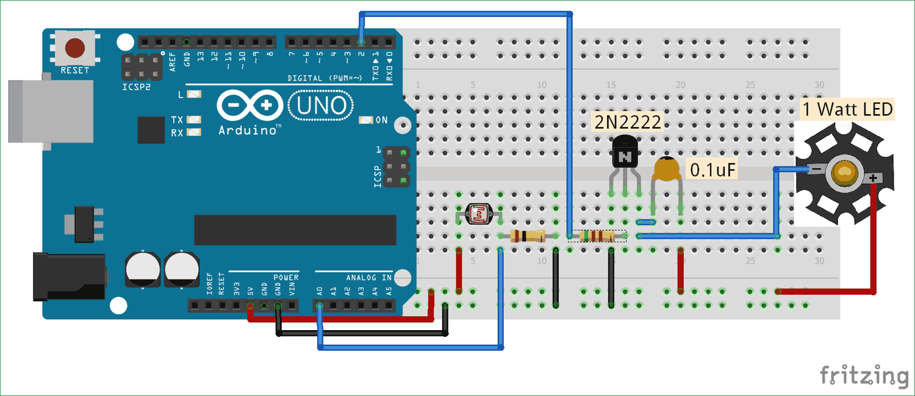

**Fig 2.1: Circuit diagram**

**2.3:Working Principle**

The working of our model is very simple. The supply is given through the power jack. From the Arduino we take 5v supply and connect it to one of the terminal of photo resistor and other end is connected to a resistor of 10k which acts as a voltage divider and then final connected to ground. The output is given by output pin 13 of the Arduino which is connected to the led through a 220ohm resistor. The other end of LED is perfectly grounded. As this is a working porotype here, we haven’t shown the usage of relays but if required they can be connected just before the lights (LEDS) for isolation purposes. The LDR senses the amount of light in the atmosphere at that moment of time and accordingly sends the data is to Arduino .The Arduino converts the data received into various discrete levels .For example from 0 to 1023 discrete levels for a given data then 0 represents maximum darkness and 1023 represents maximum brightest so light is received is converted into one of the discrete value from 0 to 1023.Now depending upon the discrete value that we get (0 to 1023) we adjust the output voltage accordingly from 0 to 5v.So,when complete darkness (night time)that is discrete level 0 than the output is 5v as a result LED is brightest or when partially dark(dawn/evening) that is discrete level of 512 then the output is 2.5 v as a result LED is half of the maximum brightest or when completely bright that is discrete level 1023 then the output voltage is 0v as a result LED switched off. Thus, the LED not only just automatically switches on and off but also adjust the amount of light emitted according to the outside condition. The usage of such kind of application in the headlights of cars, park lights, street lights is very useful.

### 2.3.1:How it Controls the Light Intensity Automatically:

As per the circuit diagram, we have made a [voltage divider circuit](https://circuitdigest.com/calculators/voltage-divider-calculator) using LDR and 100k resistor. The voltage divider output is feed to the analog pin of the Arduino. The analog Pin senses the voltage and gives some analog value to Arduino. The analog value changes according to the resistance of LDR. So, if is dark over the LDR, its resistance get increased and hence the voltage value (analog value) decreases. Hence, the analog value vary the PWM output or the duty cycle, and duty cycle is further proportional to intensity of light of power LED. So the light over the LDR will automatically control the intensity of Power LED. Below is the flow diagram how this will work, upside arrow sign is indicating "increasing" and downside arrow sign is indicating "decreasing". Intensity of light (on LDR) ↓ - Resistance↑ - Voltage at analog pin↓ - Duty cycle (PWM)↑  -**Brightness of Power LED**↑ If its full bright outside (when analog value increases more than 500) the power LED turns off.This is how you can **control the intensity of light automatically using LDR**.

**CHAPTER 3**

**ISSUES, CHALLENGES AND ANALYSIS**

**3.1 INTRODUCTION**

This overview document is designed to help the Internet Society community navigate the dialogue surrounding the Internet of Things in light of the competing predictions about its promises and perils. The Internet of Things engages a broad set of ideas that are complex and intertwined from different perspectives. Key concepts serve as a foundation for exploring the opportunities and challenges of IoT.

The term Internet of Things generally refers to scenarios where network connectivity and computing capability extends to objects, sensors and everyday items not normally considered computers, allowing these devices to generate, exchange and consume data with minimal human intervention. There is, however, no single, universal definition.

The concept of combining computers, sensors, and networks to monitor and control devices has existed for decades. The recent confluence of several technology market trends, however, is bringing the Internet of Things closer to widespread reality. These include Ubiquitous connectivity, Widespread Adoption of IP-based networking.

**3.2 SOFTWARE REQUIREMENT SPECIFICATION**

Functional requirement is a description of activities and services a system must provide. These requirements describe the interactions between the system and its environment independent of its implementation. The environment includes the user and any other external system with which the system interacts. Each is a statement of exactly what the system must do. Functional requirements that must be included in the system are listed below.

**3.2.2 SOFTWARE REQUIREMENTS**

|  |  |  |
| --- | --- | --- |
| **SNO** | **COMPONENTS** | **SPECIFICATION** |
| 1 | Operating System | Raspbian OS |
| 2 | Programming Language | C LANGUAGE |
| 3 | Applications | Browser to connect to Cloud. |

**Table 3.1:** Software Requirements

**3.2.3 HARDWARE REQUIREMENTS**

|  |  |  |
| --- | --- | --- |
| **SNO** | **COMPONENTS** | **SPECIFICATION** |
| 1 | Power Supply | +5V, 750mA Regulated Power Supply |
| 2 | Arduino UNO | Model B, 512MB RAM |
| 3 | Resistor, Capacitor, Transistor | 100kohm, 0.1uF, 2N2222 |
| 4 | Connecting wires | Male-Male, Male-Female, Female-Female |
| 5 | LDR | Light dependent resistor |
| 6 | Bulb | Temperature sensor dht11 |
| 7 | SD card | 8 GB |

**Table 3.2:** Hardware Requirements

**3.3 CONTENT DIAGRAM**

Arduino is a single-board microcontroller meant to make the application more accessible which are interactive objects and its surroundings. The hardware features with an open-source hardware board designed around an 8-bit Atmel [AVR microcontroller](https://www.elprocus.com/types-of-avr-microcontroller-atmega32-and-atmega8/)or a 32-bit Atmel ARM. Current models consists a USB interface, 6 analog input pins and 14 digital I/O pins that allows the user to attach various extension boards.

The Arduino Uno board is a [microcontroller based](http://www.edgefx.in/microcontroller-based-projects-on-car-security-systems-using-gsm/) on the ATmega328. It has 14 digital input/output pins in which 6 can be used as PWM outputs, a 16 MHz ceramic resonator, an ICSP header, a USB connection, 6 analog inputs, a power jack and a reset button. This contains all the required support needed for microcontroller.In order to get started, they are simply connected to a computer with a USB cable or with a AC-to-DC adapter or battery. Arduino Uno Board varies from all other boards and they will not use the FTDI USB-to-serial driver chip in them. It is featured by the Atmega16U2 (Atmega8U2 up to version R2) programmed as a USB-to-serial converter.

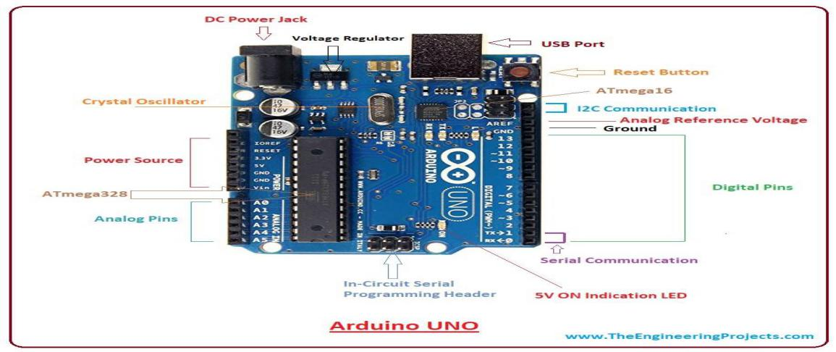

**Fig: 3.3 Arduino UNO content diagram**

* **Power USB**

Arduino board can be powered by using the USB cable from your computer. All you need to do is connect the USB cable to the USB connection

* **Power (Barrel Jack)**

Arduino boards can be powered directly from the AC mains power supply by connecting it to the Barrel Jack

* **Voltage Regulator**

The function of the voltage regulator is to control the voltage given to the Arduino board and stabilize the DC voltages used by the processor and other elements.

* **Crystal Oscillator**

The crystal oscillator helps Arduino in dealing with time issues. How does Arduino calculate time? The answer is, by using the crystal oscillator. The number printed on top of the Arduino crystal is 16.000H9H. It tells us that the frequency is 16,000,000 Hertz or 16 MHz.

* **Arduino Reset**

You can reset your Arduino board, i.e., start your program from the beginning. You can reset the UNO board in two ways. First, by using the reset button (17) on the board. Second, you can connect an external reset button to the Arduino pin labelled RESET

* **Pins (3.3, 5, GND, Vin)**
* 3.3V (6) − Supply 3.3 output volt
* 5V (7) − Supply 5 output volt
* Most of the components used with Arduino board works fine with 3.3 volt and 5 volt.
* GND (8)(Ground) − There are several GND pins on the Arduino, any of which can be used to ground your circuit.
* Vin (9) − This pin also can be used to power the Arduino board from an external power source, like AC mains power supply.
* **Analog pins**

The Arduino UNO board has six analog input pins A0 through A5. These pins can read the signal from an analog sensor like the humidity sensor or temperature sensor and convert it into a digital value that can be read by the microprocessor.

* **Main microcontroller**

Each Arduino board has its own microcontroller (11). You can assume it as the brain of your board. The main IC (integrated circuit) on the Arduino is slightly different from board to board. The microcontrollers are usually of the ATMEL Company. You must know what IC your board has before loading up a new program from the Arduino IDE. This information is available on the top of the IC. For more details about the IC construction and functions, you can refer to the data sheet.

* **ICSP pin**

Mostly, ICSP (12) is an AVR, a tiny programming header for the Arduino consisting of MOSI, MISO, SCK, RESET, VCC, and GND. It is often referred to as an SPI (Serial Peripheral Interface), which could be considered as an "expansion" of the output. Actually, you are slaving the output device to the master of the SPI bus.

* **Power LED indicator**

This LED should light up when you plug your Arduino into a power source to indicate that your board is powered up correctly. If this light does not turn on, then there is something wrong with the connection.

* **TX and RX LEDs**

On your board, you will find two labels: TX (transmit) and RX (receive). They appear in two places on the Arduino UNO board. First, at the digital pins 0 and 1, to indicate the pins responsible for serial communication. Second, the TX and RX led (13). The TX led flashes with different speed. While sending the serial data. The speed of flashing depends on the baud rate used by the board. RX flashes during the receiving process.

* **Digital I/O**

The Arduino UNO board has 14 digital I/O pins (15) (of which 6 provide PWM (Pulse Width Modulation) output. These pins can be configured to work as input digital pins to read logic values (0 or 1) or as digital output pins to drive different modules like LEDs, relays, etc. The pins labeled “~” can be used to generate PWM.

* **AREF**

AREF stands for Analog Reference. It is sometimes, used to set an external reference voltage (between 0 and 5 Volts) as the upper limit for the analog input pins.

**C LANGUAGE:**

C is a general-purpose, high-level language that was originally developed by Dennis M. Ritchie to develop the UNIX operating system at Bell Labs in 1972.C supports functions that enables easy maintainability of code,by breaking large files into smaller modules. C is very easy to learn and produces efficient programs and can handle low-level activities.

**3.4 ISSUES:**

There is a great energy crisis in current situation of our country. Moreover, people have become negligent in proper utilization of the available energy. People often forget to turn off the light sources while staying out from home and also we can find street lights turn on in day time. Even in those situations, application of intensity control of led makes it possible to control them from a distant place in easy way.

The first, is the high consumption. Each year, in the world, several trillion kWh are expended on street lighting. A high consumption means a high amount of generated energy, which in turn translates into a high level of noxious emissions.

Secondly, there are difficulties related to the maintenance of the system. How does the lighting network operator find out that a certain lamp or a component of a street-light came out of action and needs to be repaired or replaced?

Third, but no less important, is the problem related to the billing of the street lighting energy consumption. Another name for street lighting is “unmetered load” – the bills the municipalities have to pay are imprecise and are based on calculations (parameterized consumption vs working hours).

Auto intensity control of led gives the solution to save some amount of current crisis due to people’s negligence. And also helpful not only for home leds but also very useful for street lights.

**3.5 CHALLENGES:**

There are always challenges in creating and implementing smart solutions that are truly serving the needs of people and making the place attractive to live. Emerging challenges include connectivity, interoperability, data security, non-visual effects of lighting and spectral and light dosage for plant and poultry growth. Questions have arisen with respect to potential health implications of blue-rich, solid-state or compact fluorescent lighting. Short-wavelength visible light at very high intensities can be phototoxic to the retina, and the newly discovered retinal cells that influence circadian rhythm are strongly blue-sensitive. Night shift workers have a higher cancer risk, and some scientists have suggested a possible link to lighting at work that could indirectly impact cancer risk by disruption of human circadian (day-night) regulation. Changing fixture and control technologies — coupled with integration expectations and energy management demands — leaves many lighting designers hesitant to fully embrace lighting controls. Relying on manufacturers and engineers for all things “controls” related, the lighting designer can ignore a vital tool in the design and weaken their position with their clients when problems occur. Most of us take for granted that our city lights will illuminate the streets – but good-quality city lighting can also create a feeling of safety, allowing citizens to enjoy life and make the most of everything a city has to offer. Cities need to remain attractive and safe places for residents and visitors, to develop as centers of economic growth. But this must be balanced by the harsh reality of budget constraints and the requirement to lower our carbon footprint by using fewer resources.

**3.6 Future:**

The future of the smart lighting market looks promising with opportunities in the residential and commercial sectors. The global smart lighting market is expected to reach an estimated USD 17.7 billion by 2022 and is forecast to grow at a CAGR of 23.9% from 2017 to 2022. The major drivers of growth for this market are development of smart cities, increasing usage of wireless technology, and increasing awareness of energy saving. Emerging trends, which have a direct impact on the dynamics of the smart lighting industry, includes growing demand for technology and emergence of light fidelity (Li-Fi) technology in the field of smart lighting market.

**CHAPTER 4**

**METHODOLOGY**

**4.1 INTRODUCTION**

**Purpose:** System design focuses on decomposing the system into manageable parts. During system design, we focus on the processes, data structures, and software and hardware components necessary to implement it. The challenge of system design is that many conflicting criteria and constraints need to be met when decomposing the system. The purposes of object–oriented design document is to provide an overview as to how the proposed system will be used to obtain the information needed to derive the actual implementation of our system.

**Design Goals:** The objectives of Designing are to model a system with high quality and show what the system will look like after the coding is done. Which allows the programmer to do his job as a programmer and develop good and error-free system; these also give the developer, the ability to develop easily maintainable system. These way maintenance programmers can make changes to the system after it has been put into operation easily.

The field of structured design contains a number of guidelines that help designer determine which modules, and which interconnections between the modules will best implement the requirements specified in the system analysis Requirement gathering phase. The first step in designing process is to map the essential model of user requirements onto a configuration of process. Then, within each process, the designer must decide how to allocate processes and data to different tasks. Finally, we must organize the processes within each task into a hierarchy of modules, using modeling tool. The goal of system design is to manage complexity by dividing the system into smaller, manageable pieces. Embedded board is the main system which controls and connects to all other modules.

**4.2: Proposed approach and flow diagrams**

System model helps the analysts to understand the functionality of the system and models are used to communicate with the system. The system model is composed of three individual models:-The functional model: represented by use case and Scenario.

The system object model: represented by classes and objects diagrams and the dynamic model: represented by state chart and sequence diagram based on the proposed system. In this section we try to analyze the overall activity of the proposed system by using use case, sequence diagrams, activity diagrams and class diagram scenarios.

**4.2.1 Use cases and Actors**

**Use Cases:**Use case modeling identifies and describes the system functions by using a tool called use cases. Use cases describe the system functions from the perspective of external users and in a manner and terminology they understand. To accurately and thoroughly accomplish this demands a high level of user involvement and a subject matter expert who is knowledgeable about the business process or event.

Use cases are the results of decomposing the scope of system functionality into many smaller statements of system functionality. They are representing graphically by a horizontal ellipse with the name of the use case appearing above, bellow, or inside the ellipse. A use case represents a single goal of the system and describes a sequence of activities and user interactions in trying to accomplish the goal. The creation of use cases has proved to be an excellent technique in order to better understand and document system requirement, but the scenario the use case tells consists of one or more requirements.

Use cases are initially defined during the requirements stages of the life cycle and will be additionally refined throughout the life cycle. During requirements discovery, use cases are used to capture the essence of the organizational problem and to model (at a high level) the functionality of the proposed system. Additionally, they are the starting point for identifying the data entities or objects of the system.

Generally use cases describe the behavior of the system as seen from an actor’s point of view. Behavior described by the use case model is external behavior. Which mean a use case describes a function provided by the system as a set of events that yields a visible result for the actors.

**Use cases:**

* Power supply
* Raspberry Pi
* Relay Module
* Control of appliances
* Connection to switch board
* Working of appliances

**Actors:** Actors are external entities that interact with the system.Usecases are initiated or triggered by actors. An actor initiates system activities for the purpose of completing some task. An actor is a person, or external system that place a role in one or more interactions with yours system. A relationship between actors and another actor of the classes are indicated in use case diagram, a relationship exists where ever an actor is involved with an interaction described by a use case a relationship can also exist between use cases. Associations are modeled as line connecting use cases and actors to one another, with an optional arrowhead on one end of the line indicating the direction of the initial invocation of the relationship.

**Actors:**

* User

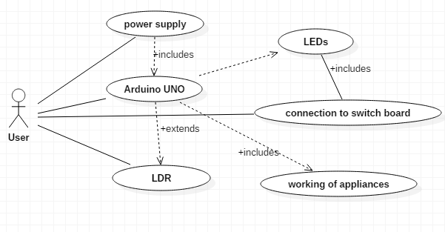

Fig 4.1: **Essential Use Case Diagram**

**4.2.2 Class Diagram**

Class diagram depicts the system’s object structure. They show object classes that the system is composed of as well as the relationships between those object classes. The UML class diagram below shows the classes of the system, their inter-relationships, and the operations and attributes of the classes.

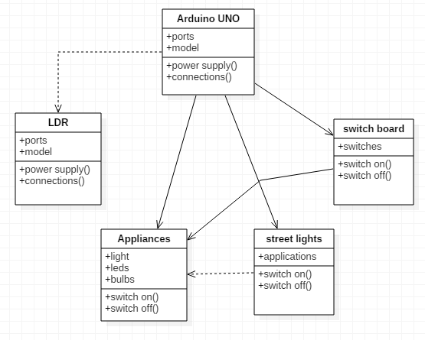

Fig 4.2 : Class Diagram

**4.2.3 Sequence Diagram**

Sequence diagrams are used to depict graphically how objects interact with each other via messages in the execution of a use case or operation. They illustrate how the operations are performed between objects and in what sequence.

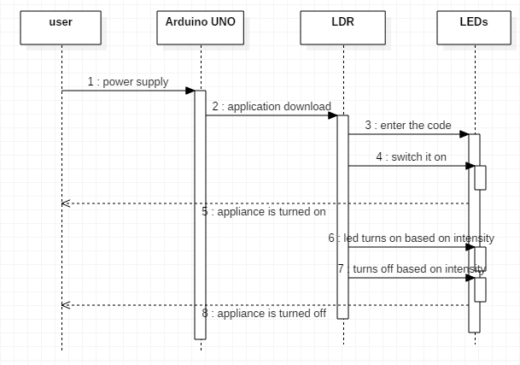

Fig 4.3: **Sequence Diagram to Record**

**4.2.4 Activity diagram**

Activity Diagrams are used to Document the logic of a single operation /methods, a single use case, or the flow of logic of a business operation. In many ways, Activity Diagrams are the object\_ oriented Equivalent of flow charts and Dataflow Diagrams (DFD) from structure development.Activity is a particular operation of the system. Activity diagrams are not only used for visualizing the dynamic nature of a system, but they are also used to construct the executable system by using forward and reverse engineering techniques. The only missing thing in the activity diagram is the message part.It does not show any message flow from one activity to another. Activity diagram is sometimes considered as the flowchart. Although the diagrams look like a flowchart, they are not. It shows different flows such as parallel, branched, concurrent, and single.

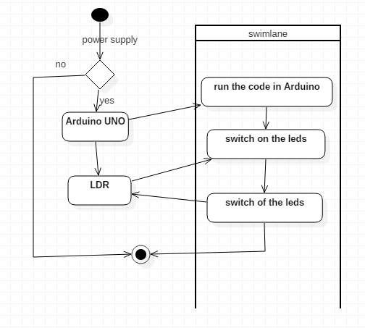

**Fig 4.4:** Activity Diagram for Computer Application

**4.2.5 Component diagram**

Component diagrams are used to visualize the organization and relationships among components in a system. These diagrams are also used to make executable systems.Component diagrams can also be described as a static implementation view of a system. Static implementation represents the organization of the components at a particular moment.A single component diagram cannot represent the entire system but a collection of diagrams is used to represent the whole.

**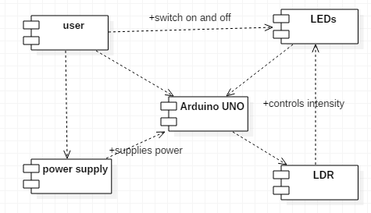**

**Fig 4.5:** Component Diagram

### Light Dependent Resistor Circuit:

The circuit of LDR is an electronic circuit built with LDR, relay, [Darlingtonpair](https://www.elprocus.com/darlington-transistor-pair-circuit-with-working/" \t "_blank), diode, & resistors shown in the below circuit diagram. A voltage supply is given to the load. The required DC voltage of the LDR circuit is supplied from a [bridgerectifiercircuit](https://www.elprocus.com/bridge-rectifier-circuit-theory-with-working-operation/" \t "_blank) or a battery. This circuit changes the AC supply into a DC. The bridge rectifier circuit uses a step-down transformer to [step-down the voltage](https://www.elprocus.com/steps-to-convert-the-230v-ac-to-5v-dc/) from 230v into 12v. The diodes are connected in the form of a bridge used to alter the AC voltage into DC. The [voltage regulator](https://www.elprocus.com/adjustable-lm317-voltage-regulator-circuit/) is used to change the 12v DC-6v DC, and then, this DC voltage is supplied to the entire circuit. A 230v AC supply for both the bridge rectifier and the load is to be kept continuously for continuous operation of the light sensor circuit.

**4.3 Module Design and Organization**

In the morning time, this sensor has a low resistance around 100Ω. Thus, the power supply flows through the LDR & ground through the variable resistor and resistor as shown in the above light sensor circuit. This is due to the resistance offered by the light dependent resistor in the daytime or when the light falls on the LDR, then it is less compared to the resistance of the remaining part of the sensor circuit .We are alert of the principle of current, that the flow of current always flow in the path of low resistance.

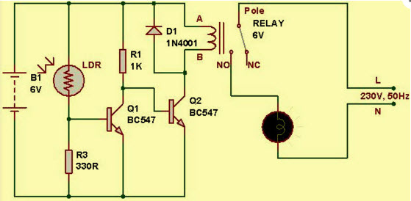

**Fig:4.6 Circuit diagram of Light Dependent Resistor**

Therefore, the relay coil does not get sufficient supplies to get strengthened. Hence, the light is switched off in the daylight. In the same way, during the night time, the resistance of the LDR increases to a high value (20MΩ). Thus, due to the high resistance of[the resistor](https://www.elprocus.com/force-sensing-resistor-technology/), the flow of current is low or almost zero.Now, the flow of current through the low-resistance lane such that it increases the base voltage of Darlington pair to reach more than 1.4v. As the Darlington pair transistor is triggered, the relay coil acquires enough supply to get energized, and hence, the light switches in the night time.

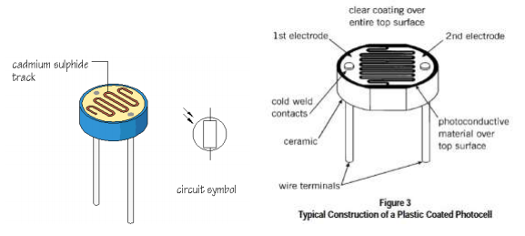 **Fig:4.7 Light Dependent Resistor**

#### **Applications of LDR:**

Light dependent resistors are simple and low cost devices. These devices are used where there is a need to sense the presence and absence of light is necessary. These resistors are used as light sensors and the applications of LDR mainly include alarm locks, street lights, light intensity meters, burglar alarm circuits. For better understanding of this concept, here we have explained one project namely; power conserving of intensity controlled street lights using LDR.

**4.4: Summary**

The view of the Design is depicted in the form of UML diagrams and the Module division is done. The detail description about the modules and their working behavior along with the connections which we make to develop the implementation design is discussed in this chapter. If any modification to be done then the design phase is effected and changed accordingly

**CHAPTER 5**

**IMPLEMENTATION**

**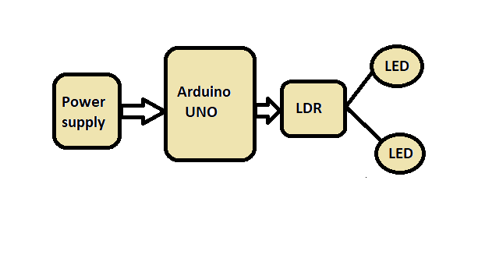**

**5.1 :** Block diagram of the Setup

#### **5.1 SYSTEM OVERVIEW:**

#### **Power Conserving of Intensity Controlled LEDs and Street Lights**

#### **using LDR:**

Nowadays, lightening-up of highways is done through HID lamps but, the energy consumption of these lights is high as well as there is no particular mechanism to turn on/off the lights from sunrise to sunset. To overcome this problem, here is an alternative method using LEDs i.e. power conserving of intensity controlled street lights using LDR.

The proposed system is built to overcome the drawback of the present day of HID lamps.The proposed system determines the usage of light emitting diodes as a light source and its adjustable intensity control according to the requirement. These lights consume less power as well as the life span of these lights is more compared to conventional HID lamps.

The most important feature of this project is, the light intensity can be controlled according to the necessity during night time, which is not possible in HID lamps. An LDR is used to detect the light and the resistance of the LDR drastically reduces according to the light in the day time,that forms as an i/p signal to the controller.

A bunch of LEDs is used to make a street light and the [microcontroller using in the project is preprogrammed](https://www.elprocus.com/pic-microcontroller-programming-using-c-language/) with instructions which controls the light intensity based on the Pulse width modulation signals generated. The light intensity is kept high during the night time, and as the traffic on the roads tend to fall in peak hours;the intensity also falls gradually till morning. Finally the LED lights get turned off at morning 6 am, and continues again at 6pm in the evening. This process will continue.

Furthermore, this project can be developed by mixing it with a solar panel, which changes the intensity of the solar to the equivalent voltage and solar energy is used to feed the lights on highways.

**System Operation**

* The User Interface of the application (Web or Android) allows the user to communicate with the Arduino over the internet.
* The end user gives the command of turning ON or OFF the specific appliance based on the intensity of light.
* The application interacts via the internet and transmits the code to the Arduino
* Arduino reads the command and sends the signal to the respected LDR. The respected LDR operates and turns the appliance ON or OFF.

**Power Supply:**

The Arduino Uno can be powered via the USB connection or with an external power supply. The power source is selected automatically. External (non-USB) power can come either from an AC-to-DC adapter (wall-wart) or battery. The adapter can be connected by plugging a 2.1mm center-positive plug into the board's power jack. Leads from a battery can be inserted in the Gnd and Vin pin headers of the POWER connector. The board can operate on an external supply of 6 to 20 volts. If supplied with less than 7V, however, the 5V pin may supply less than five volts and the board may be unstable. If using more than 12V, the voltage regulator may overheat and damage the board. The recommended range is 7 to 12 volts.

**5.2 Circuit Diagram for intensity control of Led:**

Connections are very simple,the following connections are to be applied: Connect the +5V VCC pin of the arduino to the one end of LDR fixed on the breadboard. Connect other end of the LDR to the resistor (100k) and from this end of ldr itself connect the wire to the analog pin (A0) from the arduino and the other end of the resistor is connected to ground and thus forming a potential divider circuit .(POT. can also be used in its place to det. the best resistance for LDR)

Connect the pwm digital output pin(3) of the arduino to the anode(+) of the LED and the cathode(-)of the LED is connected to ground via 1k resistor.(use different value to get stable brightness). Connect the power supply to the arduino.

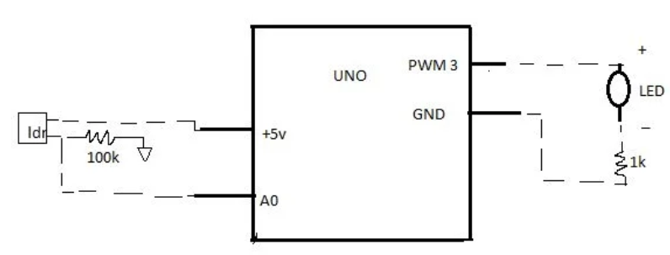

**Fig 5.2: Circuit diagram for Auto intensity control of Led**

**PROGRAMMING EXPLANATION:**

The complete **Arduino code for Automatic LED dimmer** is given at the end.

In the below code, we are defining the PWM pin and the variables to be used in the code.

**int pwmPin = 12; // assigns pin 12 to variable pwm**

**int LDR = A0; // assigns analog input A0 to variable pot**

**int c1 = 0; // declares variable c1**

**int c2 = 0; // declares variable c2**

 Now, in the *loop,*we are first reading the value using the command *“analogRead(LDR)”* then save the analog input into a variable named *“value”*. By doing some mathematic calculation we are generating the PWM signal. Here, we are controlling the intensity of light using PWM only if the analog value is less than 500, and if it is more than 500 we completely turn off the lights.

**int value = analogRead(LDR);**

**Serial.println(value);**

**c1= value;**

**c2= 500-c1; // subtracts c2 from 1000 ans saves the result in c1**

**if (value < 500)**

**{**

**digitalWrite(pwmPin, HIGH);**

**delayMicroseconds(c2);**

**digitalWrite(pwmPin, LOW);**

**delayMicroseconds(c1);**

**}**

**if (value > 500)**

**{**

**digitalWrite(pwmPin,LOW);**

**}**

**}**

**5.3 EXECUTION:**

**Controlling of leds using LDR:**

Here we are going to connect LDR (Light Dependent Resistor) to the Arduino UNO where the both devices communicate to control the intensity of light. Light Dependent Resistor is going to modulate the intensity of light based on the outside light conditions. In this we use PWM (Pulse Width Modulation) to calculate the intensity of light. If the value is less than 500 then it calculates the intensity and if it is more than 500 then the led will be totally turned off.

#### **Environment:**

C is a general-purpose, high-level language that was originally developed by Dennis M. Ritchie to develop the UNIX operating system at Bell Labs in 1972.C supports functions that enables easy maintainability of code,by breaking large files into smaller modules.C is very easy to learn and produces efficient programs and can handle low-level activities

C compiler produces machine code very fast compared to other language compilers. C compiler can compile around 1000 lines of code in a second or two and also it optimizes the code for faster execution.So, it is very much popular language and is used to design various applications as it can be compiled on a variety of computer platforms.

**Features in C:**

1. Simple
2. Machine Independent or Portable
3. Mid-level programming language
4. structured programming language
5. Rich Library
6. Memory Management
7. Fast Speed
8. Pointers
9. Recursion
10. Extensible

**Interface -Arduino software:**

* The Arduino is an open-source electronics platform based on easy-to-use hardware and software used to build electronics projects which is available for free.
* All Arduino boards have one thing in common which is a microcontroller. A microcontroller is basically a really small computer.
* With the Arduino, you can design and build devices that can interact with its surroundings. The Arduino boards are basically a tool for controlling electronics. They are able to read inputs with their onboard microcontroller (eg. Light on a sensor, an object near a sensor) and turn it into an output (Drive a motor, ring an alarm, turning on an LED, display information on an LCD).
* However, to do this, you will first have to program the Arduino board.To program a Arduino board you use a software application called Arduino IDE (integrated development environment)
* With the Arduino, makers and electricians can easily prototype their products and make their ideas come to life.

**General Directions:**

* we start the process of programming the Arduino board by downloading Arduino IDE and further by opening it we will be getting an Arduino sketch.

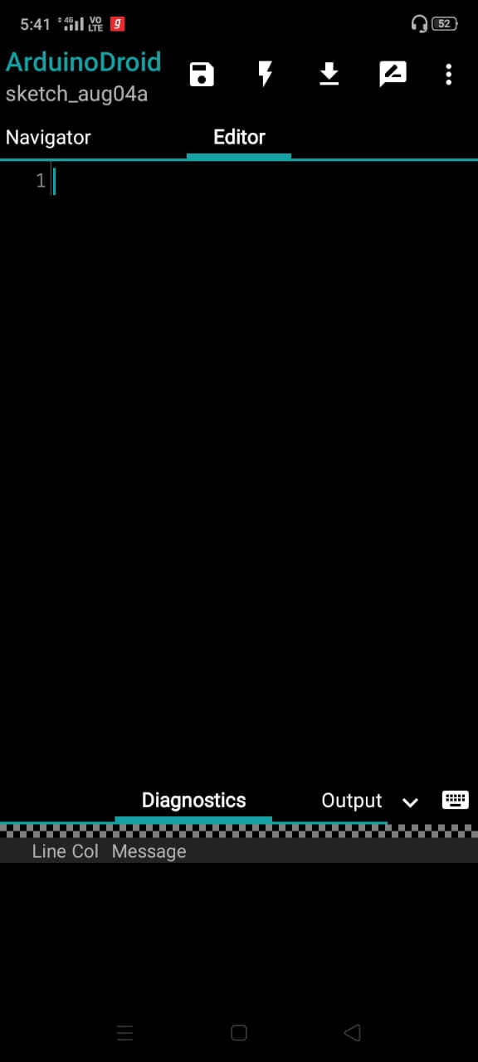 Fig:5.3- Arduino IDE sketch

* Now we should paste the code in the editor section and save the sketch.

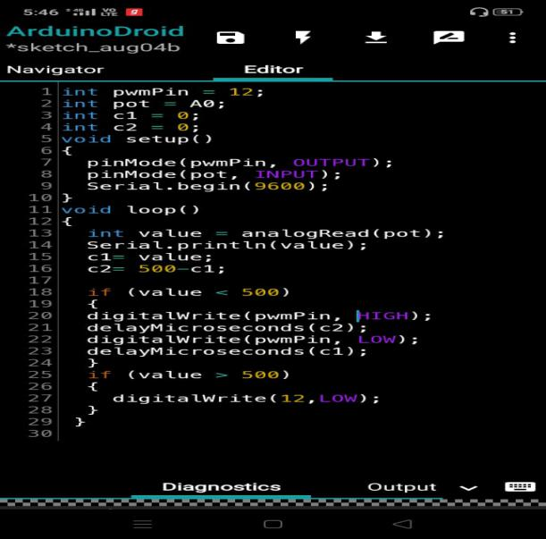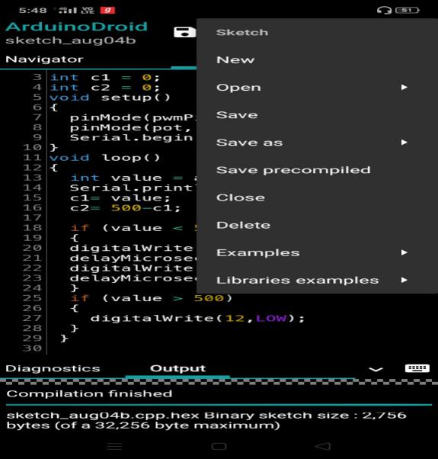

Fig:5.4-Pasting the code Fig:5.5- Saving the sketch

* Now specify the desired location to save the Arduino sketch that you have created and name the file.

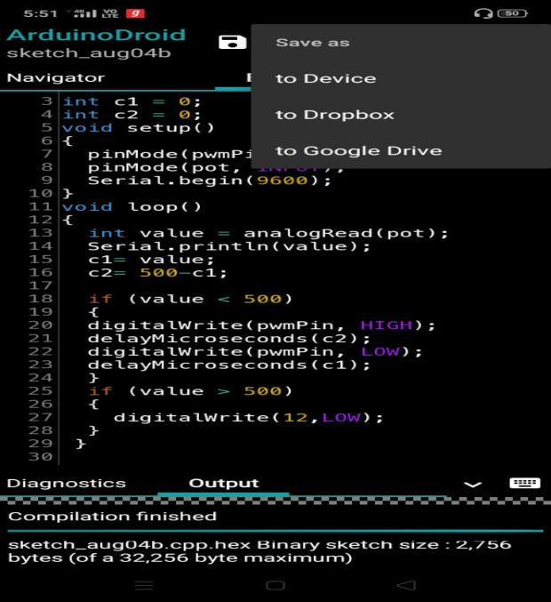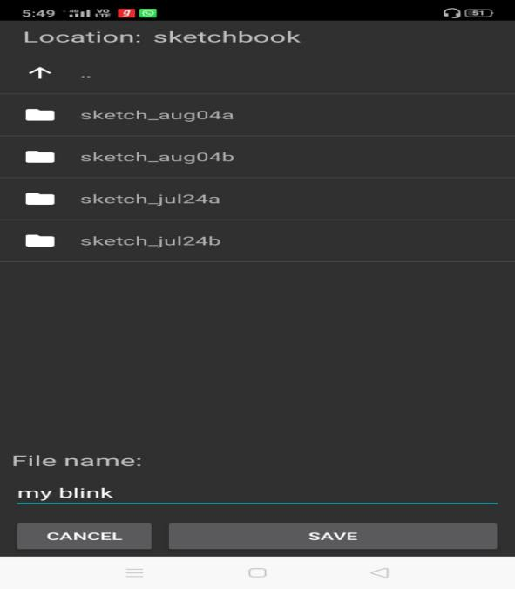

Fig:5.6-Specifying location Fig:5.7 – Naming the file

* Finally select the type of Arduino and compile the code we have saved.

If the code is perfect without errors that means if the compilation is successfully done then we will be notified as Compilation finished.

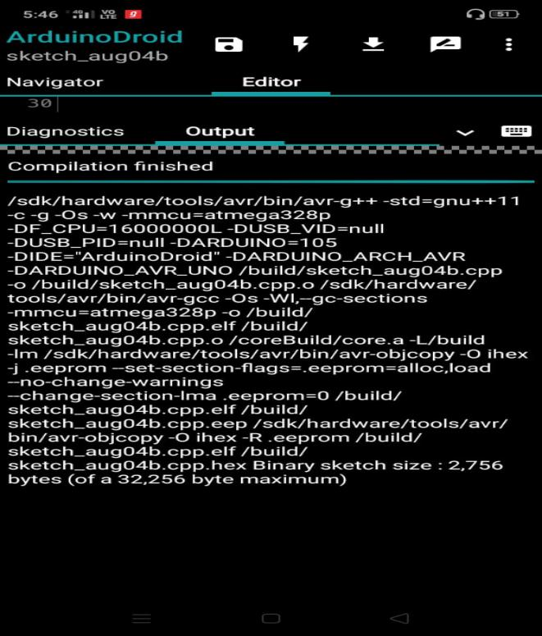

Fig:5.8-Result after Compilation

**Functions :**

**Digital I/O**

* pinMode(pin, mode)
* digitalWrite(pin, value)
* int digitalRead(pin)

**Analog I/O**

* int analogRead(pin)
* analogWrite(pin, value) – PWM

**Advanced I/O**

* shiftOut(dataPin, clockPin, bitOrder, value)
* unsigned long pulseIn(pin, value)

**Time**

* unsigned long millis()
* delay(ms)
* delayMicroseconds(us)

**Math**

* min(x, y)
* max(x, y)
* abs(x)
* constrain(x, a, b)
* map(value, fromLow, fromHigh, toLow, toHigh)
* pow(base, exponent)
* sqrt(x)

**Trigonometry**

* sin(rad)
* cos(rad)
* tan(rad)

**Random Numbers**

* randomSeed(seed)
* long random(max)
* long random(min, max)
* External Interrupts attachInterrupt(interrupt, function, mode) detachInterrupt(interrupt)
* Interrupts interrupts() noInterrupts()

**Serial Communication**

* Serial.begin(speed)
* int Serial.available()
* int Serial.read()
* Serial.flush()
* Serial.print(data)
* Serial.println(data)

**Libraries :**

To use an existing library in a sketch, go to the Sketch menu, choose "Import Library", and pick from the libraries available. This will insert one or more #include statements at the top of the sketch and allow it to use the library. Because libraries are uploaded to the board with your sketch, they increase the amount of space it takes up. If a sketch no longer needs a library, simply delete its #include statements from the top of your code.

**Official Libraries**

The "official" libraries that are included in the Arduino distribution are:

EEPROM - reading and writing to "permanent" storage

SoftwareSerial - for serial communication on any digital pins

Stepper - for controlling stepper motors

Wire - Two Wire Interface (TWI/I2C) for sending and receiving data over a net of devices or sensors.

These libraries are compatible Wiring versions, and the links below point to the (excellent) Wiring documentation.

Matrix - Basic LED Matrix display manipulation library

Sprite - Basic image sprite manipulation library for use in animations with an LED matrix

**Contributed Libraries:**

Libraries written by members of the Arduino community.

DateTime - a library for keeping track of the current date and time in software.

Firmata - for communicating with applications on the computer using a standard serial protocol.

GLCD - graphics routines for LCD based on the KS0108 or equivalent chipset.

LCD - control LCDs (using 8 data lines)

LCD 4 Bit - control LCDs (using 4 data lines)

LedControl - for controlling LED matrices or seven-segment displays with a MAX7221 or MAX7219.

LedControl - an alternative to the Matrix library for driving multiple LEDs with Maxim chips. TextString - handle strings

Metro - help you time actions at regular intervals

MsTimer2 - uses the timer 2 interrupt to trigger an action every N milliseconds.

OneWire - control devices (from Dallas Semiconductor) that use the One Wire protocol. PS2Keyboard - read characters from a PS2 keyboard.

Servo - provides software support for Servo motors on any pins.

Servotimer1 - provides hardware support for Servo motors on pins 9 and 10 Simple Message System - send messages between Arduino and the computer

SSerial2Mobile - send text messages or emails using a cell phone (via AT commands over software serial)

X10 - Sending X10 signals over AC power lines

**CHAPTER 6**

**RESULT**

In this section we have outputs and results obtained in different scenarios and different light conditions .You can also find the approximate accuracy results obtained in each case

**Results of intensity of LED based on different light conditions**

**The below images shows the intensity of LED obtained under various light conditions**

**Mainly three light conditions:**

* **During day time**
* **During evening**
* **During night time**

**Light intensity-80%:**

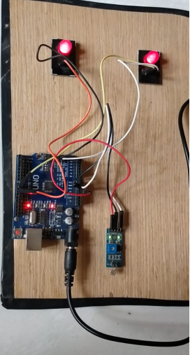

**Fig 6.1 Light intensity 80% output**

* Light intensity 80%
* Discret level 818
* Voltage 4v
* LED glows with less intensity

**Light intensity-50%:**

**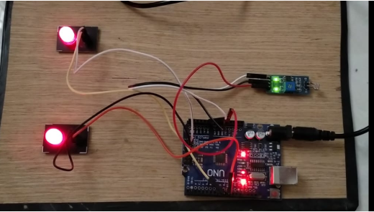**

**Fig 6.2 Light intensity 50% output**

* Light intensity 50%
* Discret value 512
* Voltage 5v
* LED glows with half of its brightness

**Light intensity-0%:**

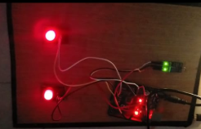

**Fig 6.3 Light intensity 0% output**

* Light intensity 0%
* Discret value 0
* Voltage 5v
* LED glows brightly

**Accuracy of light intensity**

|  |  |  |  |
| --- | --- | --- | --- |
| Light intensity | Discret level | voltage | LED intensity |
| 80% | 818 | 4v | Medium |
| 50% | 512 | 2.5v | half |
| 0% | 0 | 5v | bright |

**Table 6.1 Accuracy of light intensity**

**Comparision:**

Results comparison with other similar systems such as GSM based street light system, Street light system control by single chip microcontroller, Zigbee based system, in this system we obtained the accuracy a bit finer because it not only monitored the streetlights in Real-time but also according to the outside temperature, it has classified the intensity and responded validly.

**CHAPTER 7**

**CONCLUSION**

This project elaborates the design and construction of Arduino based LED auto intensity control system circuit. Circuit works properly to turn LED ON/OFF. After designing the circuit which controls the intensity of leds as illustrated in the previous sections LDR sensor and the photoelectric sensors are the two main components working in the circuit. If the two conditions have been satisfied the circuit will do the desired work according to specific program. Each sensor controls the turning ON or OFF the lighting column of street light. The intensity of leds has been successfully controlled by Arduino board. Street-lights are a large consumer of energy for cities using up to 30-50% of energy budget. If every city installs the proposed system then a lot of power can be saved .Proposed system is power saving mechanism for LED Street lights by using Arduino Board. It provides an effective measure to save energy by preventing unnecessary wastage of electricity, caused due to manual switching or lighting of street-lights when it is not required. It adopts a dynamic control methodology for traffic flow. The proposed system is especially appropriate for street lighting in remote urban and rural areas where the traffic is low at times. The system is versatile, extendable and totally adjustable to user needs.

**CHAPTER 8**

**FUTURE WORKS**

Looking at the current situation we can build cross platform system that can be deployed on various platforms like iOS, Windows. Limitation to control only several devices can be removed by extending automation of all other home appliances. Network can be connected to internet and Security cameras can be controlled from other places, allowing the user to observe activity around a house or business. Security systems can include motion sensors that will detect any kind of unauthorized movement and notify the user. Scope of this project can be expanded to many areas by not restricting to only home.

**CHAPTER 9**

**REFERENCES**

1. Wang Xiao-Yuan, Andrew L. Fitch, Herbert H. C. Iu, Victor Sreeramand Qi Wei-Gui “Implementation of an analogue model of a memristor based on a light-dependent resistor”2012 Chinese Physical Society and IOP Publishing Ltd Chinese Physics B, Volume 21, Number 10 International Journal of Engineering Research and General Science Volume 4, Issue 2, March- April, 2016 ISSN 2091-2730 790

2. A.A.NippunKumaar, Kiran.G, Sudarshan TSB,” Intelligent Lighting System Using Wireless Sensor Networks”, International Journal of Ad hoc, Sensor & Ubiquitous Computing (IJASUC) Vol.1, No.4, December 2010, pp 17-27

3. Y. K. Tan; T. P. Huynh; Z. Wang,” Smart Personal Sensor Network Control for Energy Saving in DC Grid Powered LED Lighting System”, IEEE Trans. Smart Grid

4. O’Reilly, Fergus, and Joe Buckley. "Use of wireless sensor networks for fluorescent lighting control with daylight substitution." Proceedings of the Workshop on Real-World Wireless Sensor Networks (REANWSN). 2005.

5. Divya, Guddeti, et al. "Design and Implement of Wireless Sensor Street Light Control and Monitoring Strategy along with GUI." IJITR (2016): 78-81.

6. Subramanyam, B. K., K. Bhaskar Reddy, and P. Ajay Kumar Reddy. "Design and development of intelligent Wireless Street light control and monitoring system along with GUI." International Journal of Engineering Research and Applications (IJERA) Vol 3 (2013): 2115-2119.

7.Fitch, Andrew Lewis, et al. "Realization of an analog model of memristor based on light dependent resistor." Circuits and Systems (ISCAS), 2012 IEEE International Symposium on. IEEE, 2012.

8. Tran, Duong, and Yen Kheng Tan. "Sensorless illumination control of a networked LED-lighting system using feedforward neural network." Industrial Electronics, IEEE Transactions on 61.4 (2014): 2113-2121.

9. Kim, Sangil, et al. "Design of lighting Fluorescent lamp and AC LED control board using MCU." Journal of the The Korean Institute of Power Electronics (2010): 252-253.

10. Song, Sang-bin, Woo-young Cheon, and Young-녀. Yu. "Design of a LED lighting bar replacement neon sign." Journal of the Korean Institute of Electrical Engineers (2006): 1671-1672.